ME 318 LAB 1
Reset 1
Given 1
Solve for x and Plot 1

Reset
close all;
clear all;
clc;

Given
t_0 = 0; % Time initial (s)
t_f = 10; % Time final (s)
x_0 = [0 + 0.01, 0; % Initial conditions (m, m/s)
4 + 0.01, 0;
-4 - 0.01, 0;
sqrt(40) - 0.01, 0;
sqrt(40) + 0.01, 0];

Solve for x and Plot
options = odeset('RelTol', 1E-6, 'AbsTol', 1E-9);
for i = 1:length(x_0)
% ODE45
[t, x] = ode45(@EOM, [t_0, t_f], x_0(i, :), options);
% Plot
figure;
plot(t, x(:, 1), 'LineWidth', 2);
title(['Case ', num2str(i), ' Displacement vs. Time']);
xlabel('Time (s)');
ylabel('Displacement (m)');
end
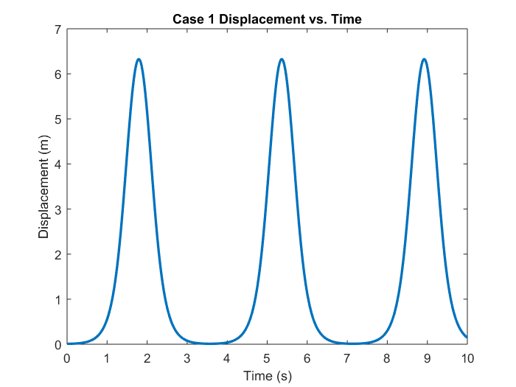
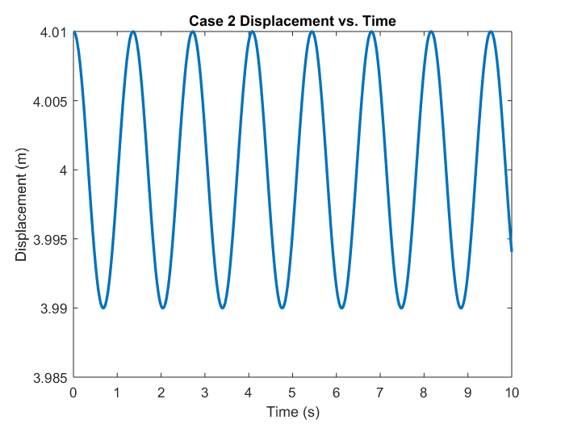
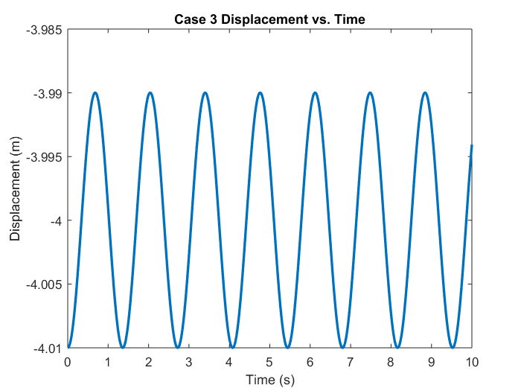
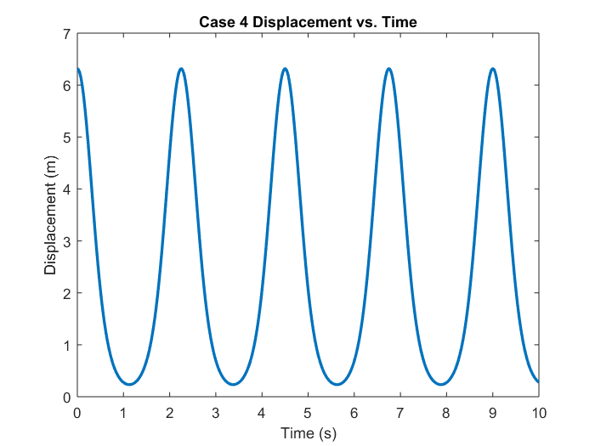
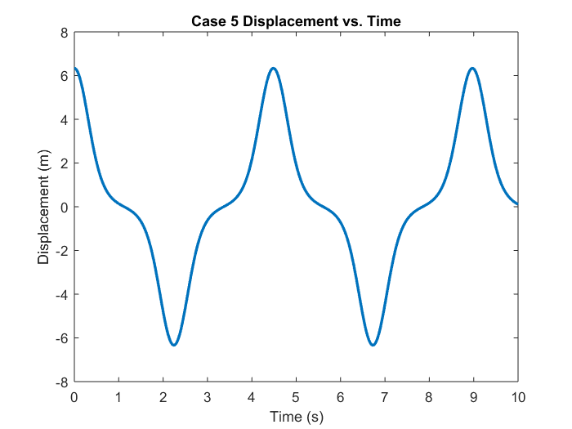
Published with MATLAB® R2017a

